Networking Essential - Learning note (Day2)
Date: 18/11/2025

- Summary of what I learned

I reviewed the fundamental concepts of computer networking and how data moves across the internet. Key points include:
- How IP addressing works( Classes of IPv4 addresses - A,B,C,D and E. And the categories - Public and Private )
- Basics of subnetting and why networks are divided into smaller segments
- Understanding layer 2 Mac addresses and layer 3 Ip addresses.
- How routers and switches operate in a network and how they aid communications.
- The difference between the OSI model(7 layers) and the TCP/IP model (4 layers)
- The Purpose of common ports and protocols (HTTP,DNS,SSH,FTP,SMTP etc.).
- How packets are encapsulated and travel from one device to another.

Networking is the backbone of cybersecurity, because every attack,threat, or incident occurs on a network.

- Top Protocols and What They Do

Port | Protocol | Purpose
80 | HTTP | Web browsing (Unencrypted)
443 | HTTPS | Web browsing (encrypted)
21/22 | FTP | File transfer
53 | DNS | Converts domain name to ip address
25 | SMTP | Sending emails
110 | POP3 | Retrieves email and delete the email from the server
143 | IMAP | Retrieves email and keeps master copy on the server
3389 | RDP | Remote desktop login
22 | SSH | Remote login and command  execution(Secured)
23 | TELNET | Remote login and command  execution(unsecured)
445 | SMB | Enables files and resources sharing between nodes on a network.
123 | NTP | Used to synchronize computer clock on a network

- Quick Explanations (My Own Words )

- How DNS Works(Short explanation)
Domain name system (DNS) is like a dictionary that maps a domain name to an ip address. When you type a website name (e.g facebook.com), DNS converts the domain name to an IP address so your browser can reach the correct server.

- What a packet is
A packet is a small unit of data. Anything sent across the internet (images, videos, files, messages) are broken down into packets, transmitted, and and reassembled at the destination.

- Switch vs Router
A switch connects devices in a Local Area network(LAN). It forwards data frames based on layer 2 MAC addresses. It builds and maintains a MAC address table to efficiently deliver data frames to the right device. By default, a layer 2 switch creates a broadcast domain, but with the use of VLANs, it can segment a network into multiple broadcast domains.
A Router connects multiple networks together. It forwards data packets based on layer 3 IP address. It determines the best path for sending data packets using ip addresses and routing tables.

- Mini - Projects Completed Today

- Project 1: Network Diagram Creation
I created a simple network diagram using Draw.io to show how basic networking devices connect inside a small network. The diagram Includes:
- Users
- Switch
- Router
- Firewall
- Server

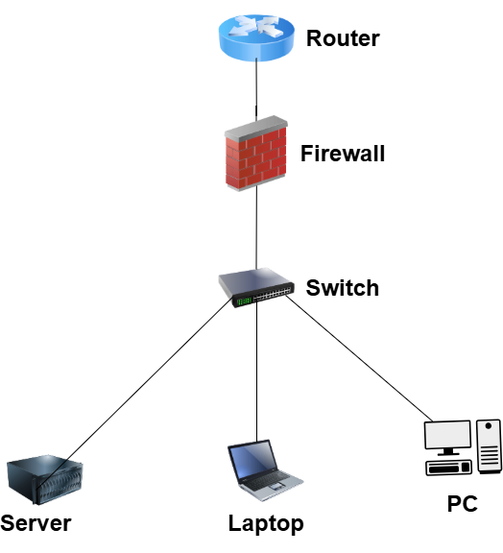

- Project 2: TCP 3-Way Handshake Diagram
A hand drawn representation of the TCP connection establishment process showing:
- SYN packet(Seq = a) from Client > Server
- SYN/ACK packet(Seq = b, ACK = a+1) from Server > Client
- ACK packet (ACK = b+1) from Client > Server
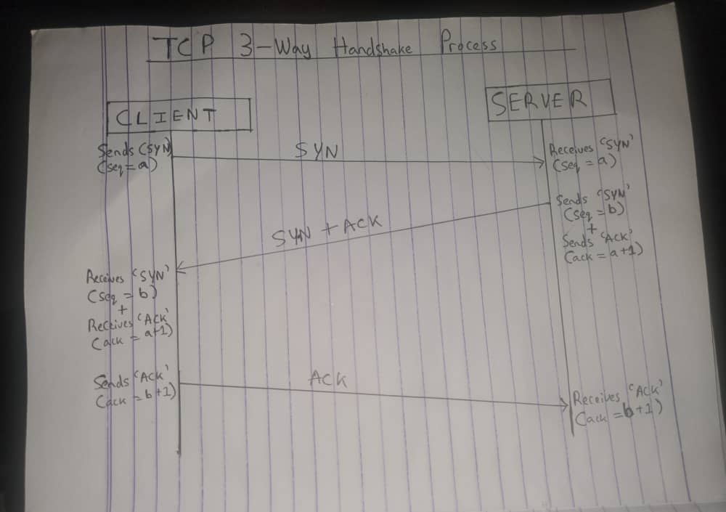

- Project 3: 20 Common Ports List
I documented a list of important ports used in cybersecurity investigation

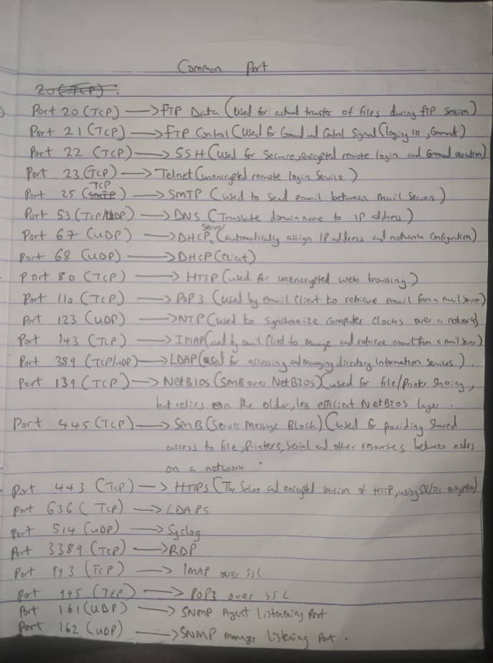

5. Why Networking Matters For SOC Analysts
A SOC analyst must understand networking because attackers exploit network systems. Networking knowledge helps SOC analyst:
- Identify suspicious traffic in SIEM alerts
- Understand how malware communicates (C2 traffic)
- Investigate DDoS, Portscanning, MITM and DNS poisoning.
- Analyze LOgs from firewalls, routers, VPNs,web servers, and endpoints.
- Detect anomalies like unusual ports, traffic spikes, or strange IP addresses.
Without networking fundamentals, a SOC analyst cannot interpret logs or detect threats effectively.

- Five Questions I Still Have.
- How does a SOC analyst differentiate between normal and abnormal DNS traffic?
- Which network protocols are most commonly used in cyberattacks?
- How does VLAN segmentation help prevent lateral movement?
- What tools do SOC analysts use to analyze packet captures besides Wireshark?
- How does encrypted traffic inspection work on enterprise firewalls?

- What I will Improve or Study Next
- Explore common attack techniques that abuse ports and protocols
- Learn deeper subnetting
- Practice analyzing more packet captures

